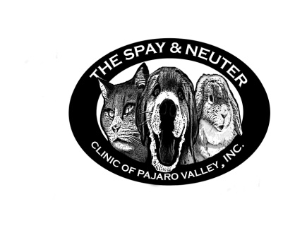
The Spay and Neuter Clinic of Pajaro Valley, Inc.
150 A Pennsylvania Dr.
Watsonville, CA 95076
(831)818-5007
thespayandneuterclinicofpv.com
thespayandneuterclinicofpv@gmail.com

CONSENT FOR ANESTHESIA AND SURGICAL STERILIZATION

I, being of legal age and responsible for the animal(s) described below, authorize The Spay and Neuter Clinic of the Pajaro Valley, Inc. and it’s staff members, volunteers, and/or agents to surgically sterilize the animal named below. Furthermore, if I am unable to provide proof of rabies vaccination for dogs and cats over 4 months of age, I agree to the administration of that vaccination in accordance with California Statues.

I understand that the above-mentioned will use all reasonable precautions while administering anesthesia and performing surgery. I understand the risks involved and that circumstances can arise beyond such reasonable precautions. I therefore agree that above mentioned will not be held responsible in the event of this animal’s injury, escape or death. In addition, I promise to indemnify, defend and hold harmless The Spay and Neuter Clinic of Pajaro Valley, Inc. and its agents.

I understand that this animal has passed or will pass a brief health examination conducted by a veterinarian prior to undergoing it’s surgery. However, this animal still may have underlying medical problems that may complicate anesthesia and surgery. I understand that I am financially responsible for vaccines, blood work and all the other services requested by The Spay and Neuter Clinic of Pajaro Valley, Inc.

I further understand that as long as, in the opinion of the attending veterinarian, the animal is an acceptable surgical candidate, sterilization procedures will be performed regardless of the animal’s sex or medical condition (including pregnancy). I understand that the attending veterinarian can refuse to perform any procedure on any animal for any reason. Such refusal is at the sole discretion of the attend veterinarian. I understand that animals sterilized may be identified with a permanent tattoo.

I understand that the above anesthetic and surgical, diagnostic or therapeutic procedures may involve risk of complications, injury or even death, from both known and unknown causes and no warranty or guarantee has been either expressed or implied as to result or cure. Furthermore, I authorize the hospital staff in an emergency situation, to follow through with such procedures as are necessary for the well being of my pet on a continuing basis until further communication with me. If in the course of treatment a condition is discovered with requires medical attention or an additional procedure, such as hernia repair or the administration of IV fluids, the attending veterinarian may, in his/her absolute discretion, perform such procedure. I consent to these procedures.

I understand that animals must be picked up after surgery in the late afternoon the day of surgery. I understand that there will be additional boarding fee of $40.00 per night for animals not picked up at the assigned time and day. If I fail to reclaim the animal within 1 business day of the designated pick up date, I waive my claim to said animal and authorize The Spay and Neuter Clinic of Pajaro Valley, Inc., as its sole discretion, to disposition the animal appropriately.

I understand that due to the stress levels animals experience in a shelter environment, upper respiratory infections may develop. I also understand that if symptoms occur, I need to contact my personal veterinarian.

In the event that this animal has problems at home, I will get veterinary attention for the animal in a timely manner and I acknowledge that this care and any further care will be at my own expense.

Once you have signed your pet up for the low-cost spay/neuter, there are NO refunds!

My signature below indicated that I have read the above information and agree to the terms and have received a copy of the client instructions.

Owner Name (Print)___________________________________________________

Signature:__________________________ Date:___________________________

Phone number:( )_________________ Animal name:____________________

Species: Dog/Cat/Rabbit Animal ID#:_____________________

Staff initials indicating that client instructions given: ____________

Appointment date and dropoff time:_______________________________________

Clinic use only

Cat F/M FVRCP Rabies Microchip Other:

Dog F/M DA2PP Rabies Microchip Other:

